Nora Bogart

Professor McCabe

Data Science for Political Science

16 December 2021

Public Opinion COVID-19 Vaccine Implementation in March 2021

My research question asks is there one specific race or political party that is more or less likely to get the COVID-19 vaccine? Additionally, what factors play a role in those who get vaccinated? These factors include their view on the pandemic, proximity to a vaccination center, how often they wear a mask, and so on. The variables in the study will be used to determine what races are more or less likely to get vaccinated and to make inferences about why that is. The key results of my findings suggest that Republicans are less likely to be fully vaccinated and White individuals are less likely to be vaccinated in proportion to Black respondents.

This research question is important because COVID-19 is impacting our entire society. Looking at what factors influence who decides to get vaccinated is vital in targeting those groups who are apprehensive about getting vaccinated. My initial theory was that Republicans are less likely to get vaccinated and Black respondents are getting vaccinated at a slower rate. Blacks and Hispanics may not have the resources to get the vaccine. However, I believe that a large share of Republicans are opposed to getting the vaccine. Race and partisanship will be the two large factors that I focus on when trying to answer my research question.

According to an article that targeted vaccination rates in rural Tennessee, the author concluded that those who are hesitant to get vaccinated mostly identify as white, rural, Republican, and evangelical Christian. Approximately 40% of Tennessee residents are vaccinated and this low number may be attributed to the southern culture. 33.1% of Black individuals responded as being fully vaccinated and 37.7% by White respondents. Donald Alcendor also stated that urban parts of Tennessee were more prone to getting the vaccine (Alcendor).

The Kaiser Family Foundation conducted this survey and most of the respondents were black and white individuals. There were 1,038 white respondents and 532 black respondents out of the total 1,862 respondents. The data was collected by asking people a series of questions. These questions ranged from their age, political affiliation, who they voted for in the last election, how concerned they are about COVID-19, if they themselves have ever had COVID-19, their proximity to a vaccination center, and more. White respondents make up nearly double the black respondents. I found that 27.26% of White respondents are fully vaccinated and 25.94% of Black respondents are fully vaccinated. Proportionally, that number shows that there is still a large majority of White respondents who are not vaccinated. Below is a chart that shows the comparison between Black and White respondents.

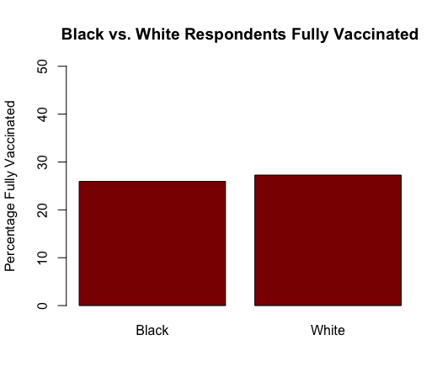

Although this may appear to look close in vaccination status, there was nearly double the number of White respondents in this study.

Another big part of my research question focused on partisanship and how that affected those who got the vaccine. I only looked at Republicans and Democrats and ignored Independents for this section. There were 342 Republicans and 731 Democrats in this data set. The total number of those fully vaccinated, either receiving both doses of a two-dose vaccine or one dose of a one-dose vaccine, was 479. Below is a barplot that indicates how Republicans are significantly lower than Democrats in being fully vaccinated.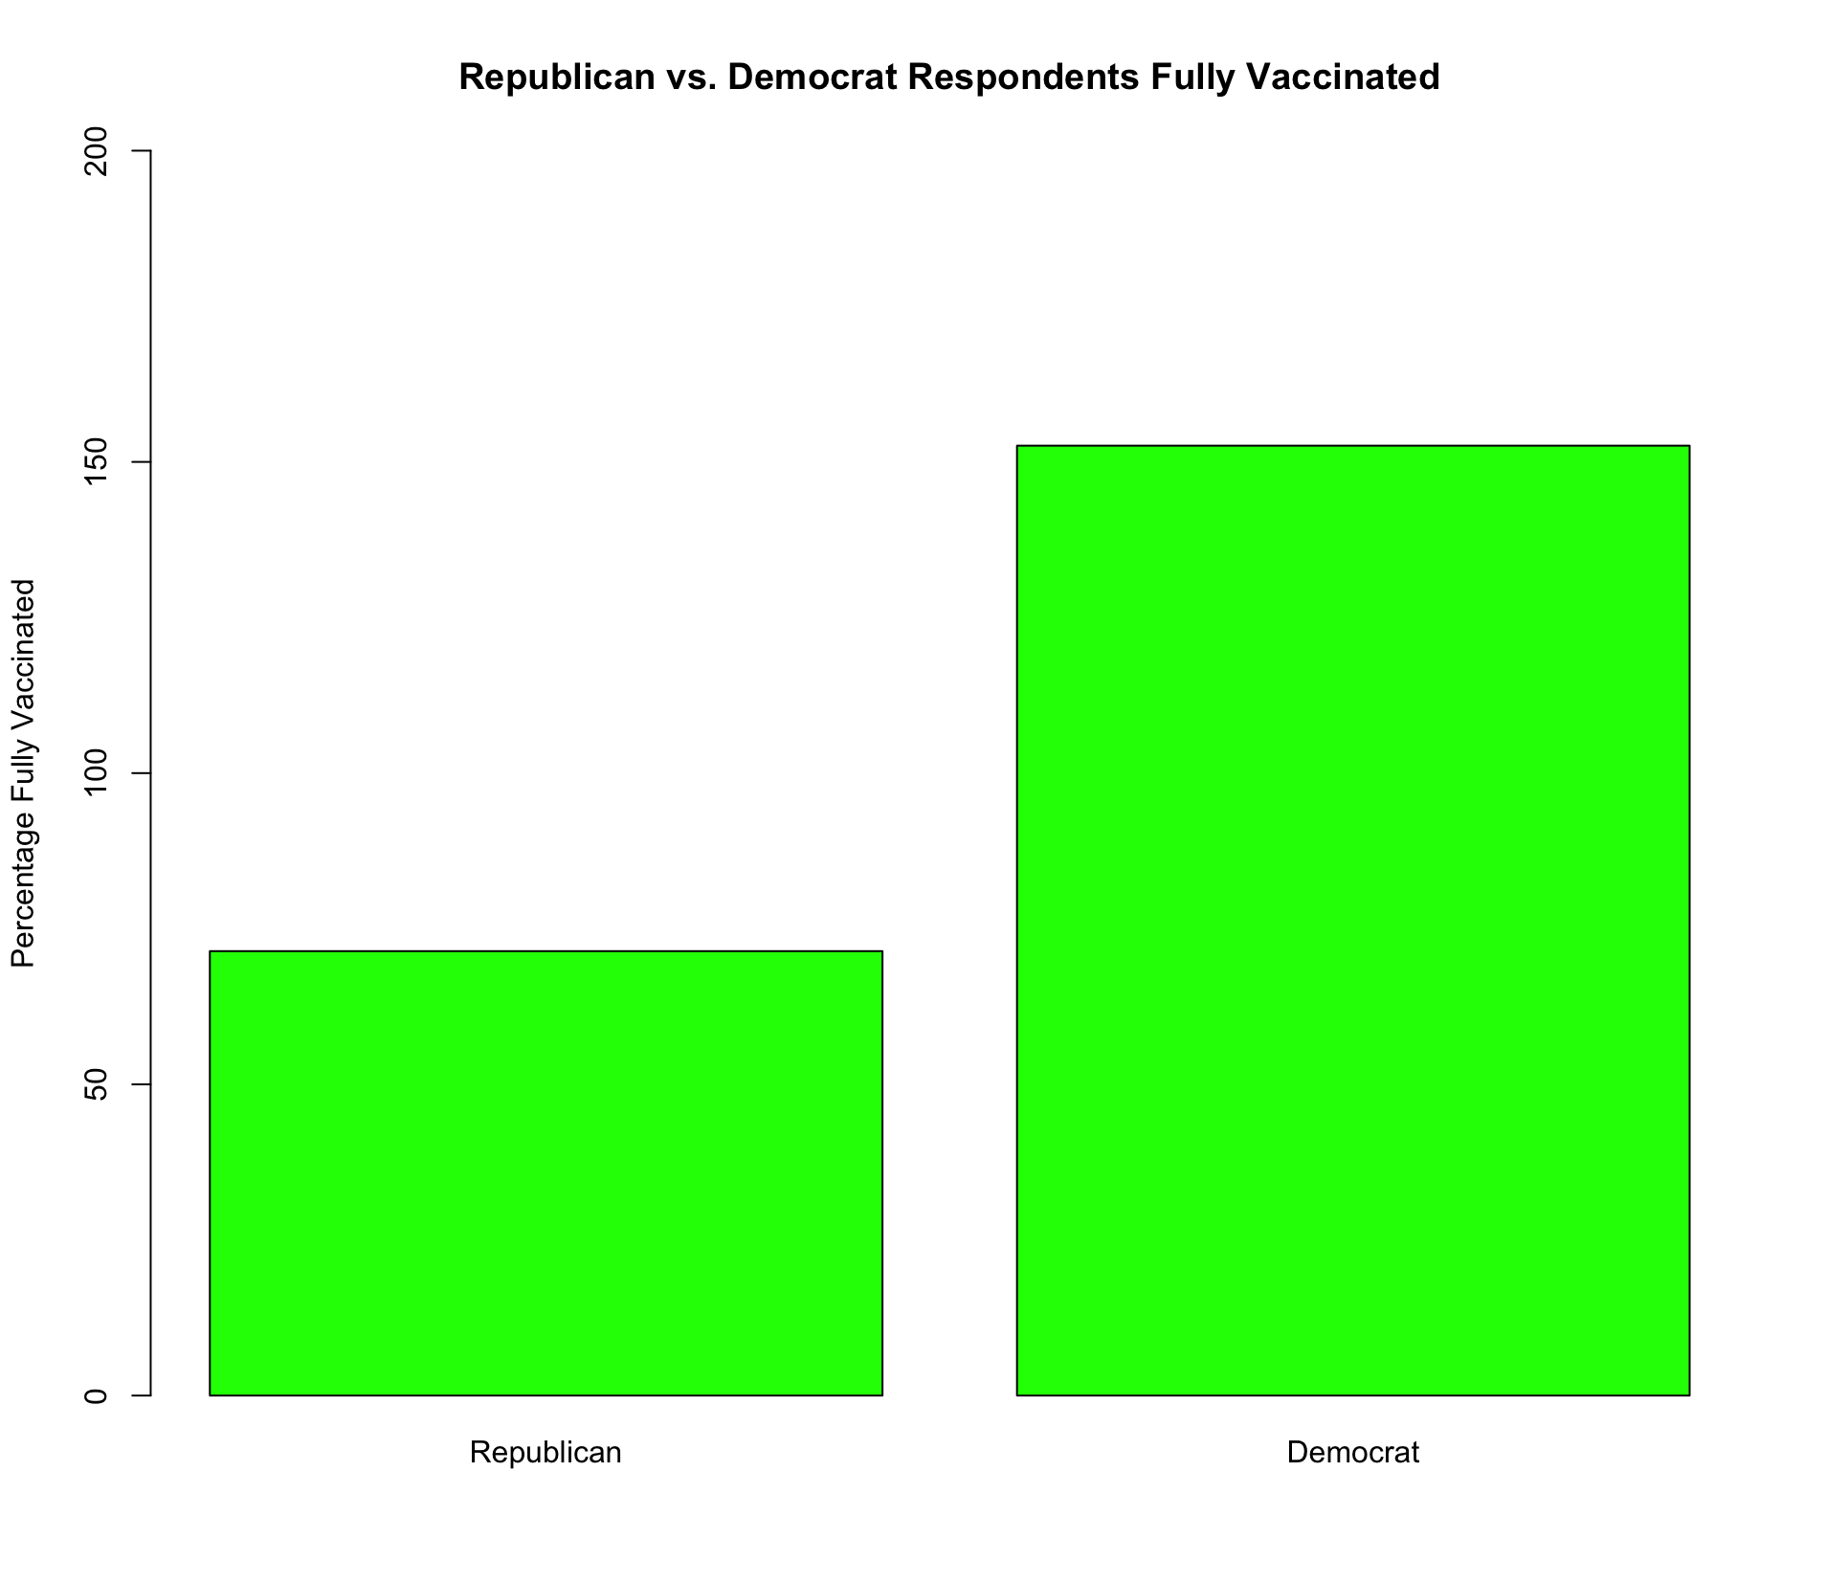

According to this barplot, Republicans are at about 71% fully vaccinated while Democrats were just over 150%. Democrats did make up a larger portion of respondents in this study. I took the sum of Republicans and Democrats and divided it by the total number of fully vaccinated respondents. As with the Tennessee article that was mentioned earlier, I saw similar results in my findings.

In conclusion, my research question sought to discover if race or partisanship played a role in vaccination status. My findings suggest that White respondents and Republicans are more hesitant to get vaccinated. It’s unclear what the driving force behind these findings is but some assumptions could be made that religion or region in the United States are key factors. Some limitations to this study would be the data pool. Perhaps a more evenly split group of people would have made this easier to analyze. In addition, a more concise set of questions might have made it easier to analyze the reason behind my findings. There were 194 columns, or questions, in this study which made it difficult to sort which questions were the most important to focus on. These findings are important because if the United States continues to lag in vaccination rates, the coronavirus will continue to mutate and make the current vaccine procedure that we have in place less effective. The virus will get stronger and it will continue to hospitalize and kill American citizens.

Works Cited:

Alcendor, Donald J. “Targeting COVID Vaccine Hesitancy in Rural Communities in Tennessee: Implications for Extending the COVID-19 Pandemic in the South.” *Vaccines (Basel)*, vol. 9, no. 11, MDPI, 2021, p. 1279–, https://doi.org/10.3390/vaccines9111279.